## Bank Database

**Question**

* Branch (branch-name: String, branch-city: String, assets: real)
* BankAccount(accno: int, branch-name: String, balance: real)
* BankCustomer (customer-name: String, customer-street: String, customer-city: String) **-**

Depositer(customer-name: String, accno: int)

* LOAN (loan-number: int, branch-name: String, amount: real)
* Create the above tables by properly specifying the primary keys and the foreign keys. Enter at least five tuples for each relation.
* Display the branch name and assets from all branches in lakhs of rupees and rename the assets column to 'assets in lakhs'.
* Find all the customers who have at least two accounts at the same branch (ex. SBI_ResidencyRoad).
* Create a viewwhich gives each branch the sum of the amount of all the loans at the branch.

### Schema Diagram

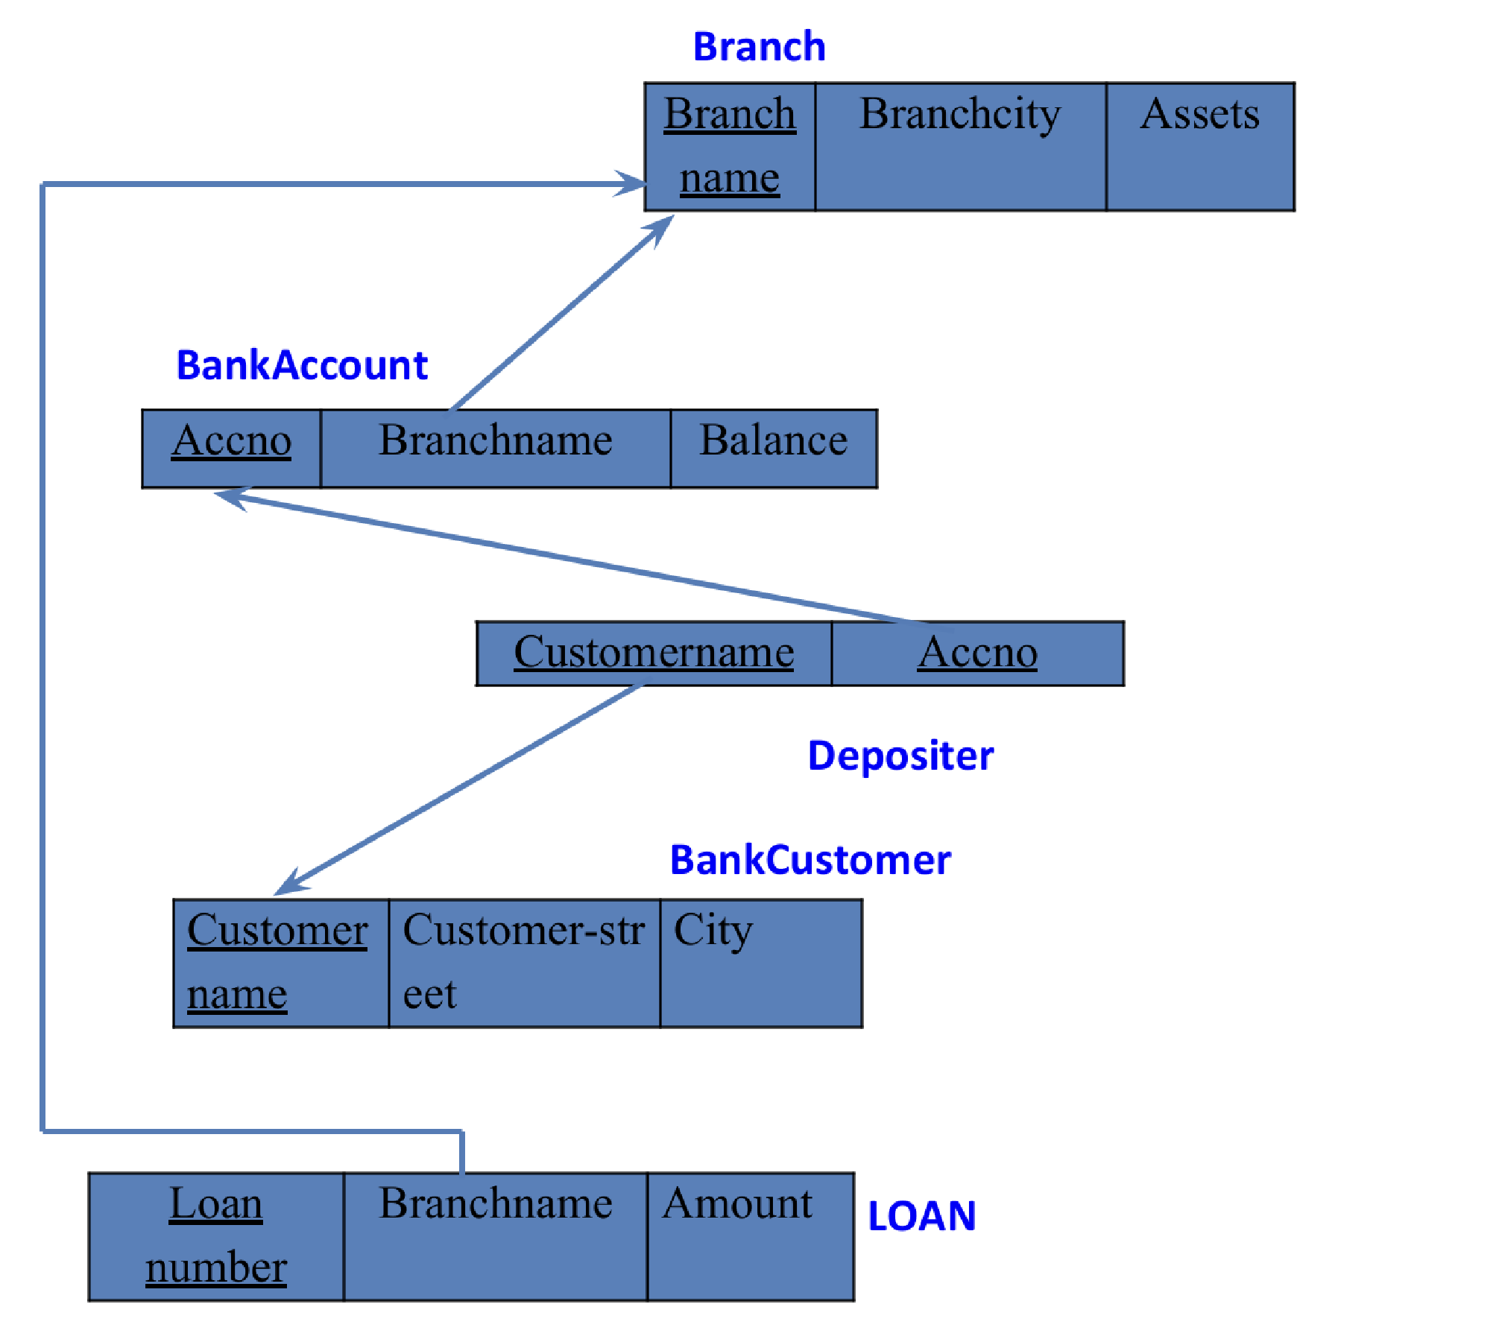

### Create database

### create database bank_database_1BM23CS081;

### use bank_database_1BM23CS081;

### Create table

### create table BRANCH_081(

### branch_name varchar(100),

### branch_city varchar(100),

### assets real,

### primary key (branch_name));

### create table BANK_ACCOUNT_081(

### acc_no int,

### branch_name varchar(100),

### balance real,

### primary key(acc_no),

### foreign key(branch_name) references BRANCH_081(branch_name));

### create table BANK_CUSTOMER_081(

### customer_name varchar(100),

### customer_street varchar(100),

### customer_city varchar(100),

### primary key(customer_name));

### create table DEPOSITOR_081(

### customer_name varchar(100),

### acc_no int,

### primary key(customer_name, acc_no),

### foreign key(acc_no) references BANK_ACCOUNT_081(acc_no),

### foreign key(customer_name) references BANK_CUSTOMER_081(customer_name));

### create table LOAN_081(

### loan_number int,

### branch_name varchar(100),

### amount real,

### primary key(loan_number),

### foreign key(branch_name) references BRANCH_081(branch_name));

### Structure of the table

BRANCH_081

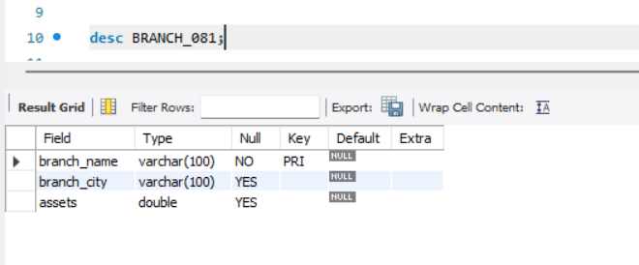

BANK_ACCOUNT_081

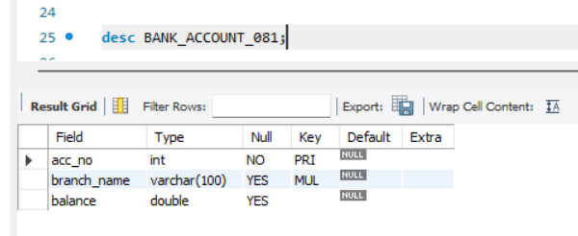

### BANK_CUSTOMER_081

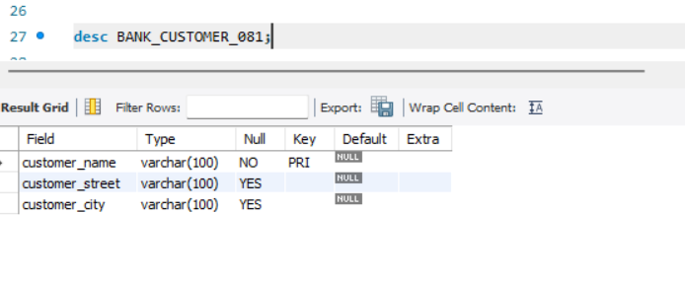DEPOSITOR_081

### 

LOAN_081

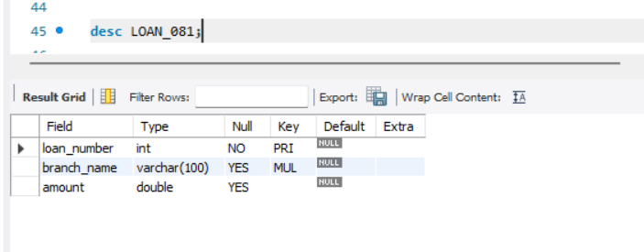

### Inserting Values to the table

insert into BRANCH_081(branch_name, branch_city, assets)

values ("SBI_Chamrajpet", "Bangalore", 50000),

("SBI_ResidencyRoad", "Bangalore", 10000),

("SBI_Shivaginagar", "Bombay", 20000),

("SBI_ParlimentRoad", "Delhi", 10000),

("SBI_Jantarmantar", "Delhi", 20000);

insert into BANK_ACCOUNT_081(acc_no, branch_name, balance)

values (1, "SBI_Chamrajpet", 2000),

(2, "SBI_ResidencyRoad", 5000),

(3, "SBI_Shivaginagar", 6000),

(4, "SBI_ParlimentRoad", 9000),

(5, "SBI_Jantarmantar", 8000),

(6, "SBI_Shivaginagar", 4000),

(8, "SBI_ResidencyRoad", 4000),

(9, "SBI_ParlimentRoad", 3000),

(10, "SBI_ResidencyRoad", 5000),

(11, "SBI_Jantarmantar", 2000);

insert into BANK_CUSTOMER_081(customer_name, customer_street,customer_city)

values ("Avinash", "Bull Temple Road", "Bangalore"),

("Dinesh", "Bannergatta Road", "Bangalore"),

("Mohan", "National College Road", "Bangalore"),

("Nikil", "Akbar Road", "Delhi"),

("Ravi", "Prithiviraj Road", "Delhi");

insert into DEPOSITOR_081(customer_name, acc_no)

values ("Avinash", 1),

("Dinesh", 2),

("Nikil", 4),

("Ravi", 5),

("Avinash", 8),

("Nikil", 9),

("Dinesh", 10),

("Nikil", 11);

insert into LOAN_081(loan_number, branch_name, amount)

values (1, "SBI_Chamrajpet", 1000),

(2, "SBI_ResidencyRoad", 2000),

(3, "SBI_Shivaginagar", 3000),

(4, "SBI_ParlimentRoad", 4000),

(5, "SBI_Jantarmantar", 5000);

**Inserted Values**

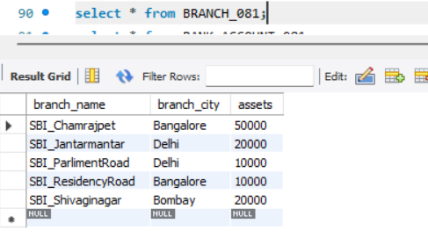

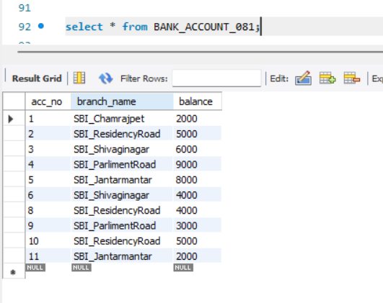

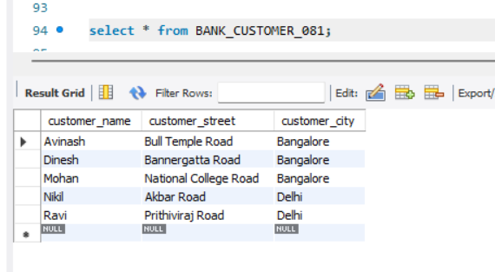

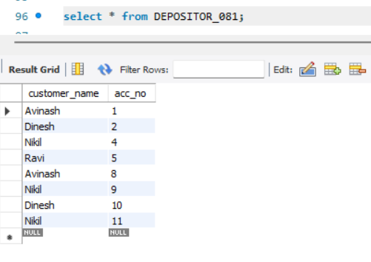

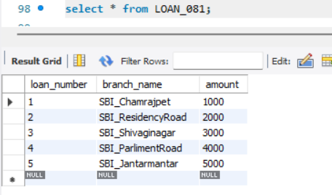

### Queries

**1.Display the branch name and assets from all branches and rename the assets column to 'assets in lakhs'.**

Query : select branch_name, assets/100000 as assetsinlakhs from BRANCH_081;

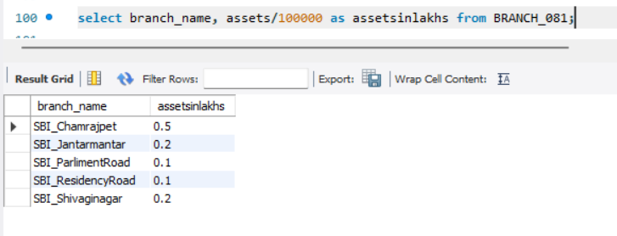

**2.Find all the customers who have at least two accounts at the same branch (ex.SBI_ResidencyRoad).**

Query : select d.customer_name, b.branch_name, count(d.acc_no) as account_no

from DEPOSITOR_081 d, BANK_ACCOUNT_081 b

where d.acc_no=b.acc_no

group by d.customer_name, b.branch_name

having count(d.acc_no)>=2;

